# Queries

/*1. Select all columns and all rows from one table.*/

SELECT /*fixed*/ * FROM Instr_Info;

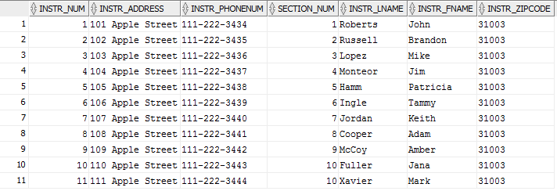

/*2. Select 5 columns and all rows from one table. */

SELECT /*fixed*/ Sched_Num, Sched_Day, Sched_Time, Sched_Day_Off, Sched_Notes FROM Class_Sched;

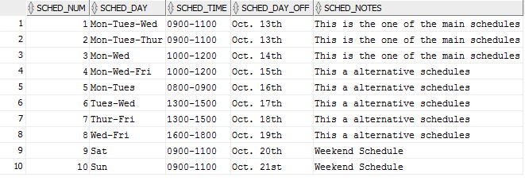

/*3. Select all columns and all rows from 2 tables (need a join).*/

SELECT /*fixed*/ * FROM Section_Info INNER JOIN Course_List USING (Section_Num);

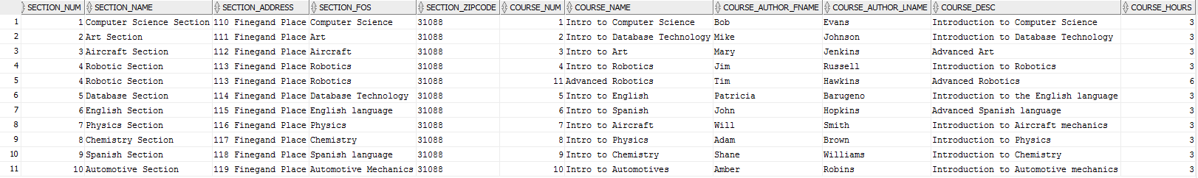

/*4. Select and Order data retrieved from one table */

SELECT /*fixed*/ * FROM Instr_Info ORDER BY Instr_LName;

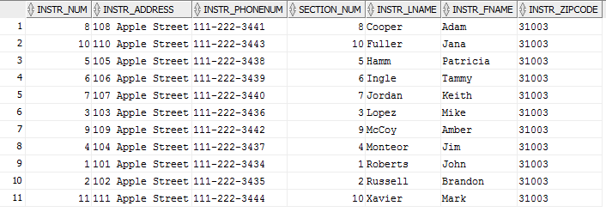

/*5. Select 5 columns and 10 rows from 3 tables (need joins).*/

SELECT /*fixed*/ a.Instr_LName, a.Instr_FName, b.Class_Room, c.Sched_Day, c.Sched_Time

FROM (Instr_Info a INNER JOIN Instr_Classes b ON a.Instr_Num=b.Instr_Num)

INNER JOIN Class_Sched c ON b.Sched_Num=c.Sched_Num

WHERE ROWNUM < 11;

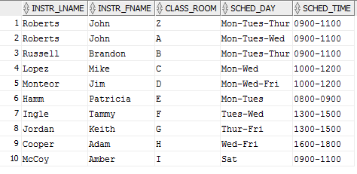

/*6. Select distinct rows using joins using 3 tables.*/

SELECT DISTINCT /*fixed*/ a.Instr_LName, a.Instr_FName, c.Course_Name

FROM (Instr_Info a INNER JOIN Instr_Classes b ON a.Instr_Num=b.Instr_Num)

INNER JOIN Course_List c ON b.Course_Num=c.Course_Num;

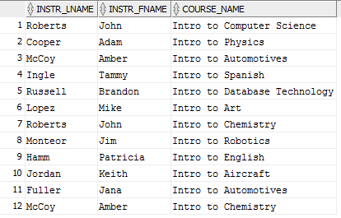

/*7. Select all columns and 10 rows from 2 tables (need a join).*/

SELECT /*fixed*/ * FROM Section_Info INNER JOIN Instr_Info ON

Section_Info.Section_Num=Instr_Info.Section_Num

WHERE ROWNUM < 11;

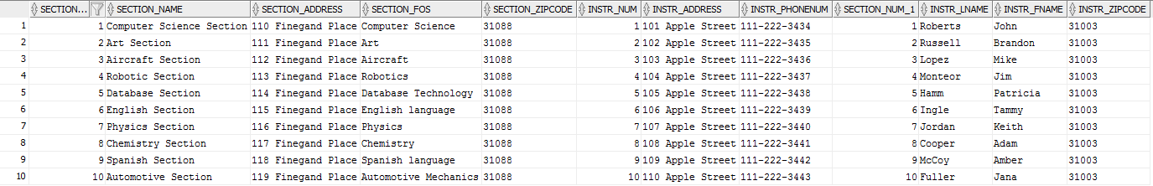

/*8. Use group by & having in a select statement using one or more table(s).*/

SELECT /*fixed*/ Course_Name, AVG(Course_Hours) FROM Course_List

GROUP BY Course_Name

HAVING AVG(Course_Hours) = 3;

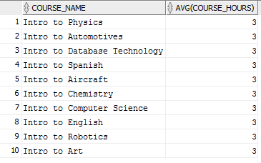

/*9. Use a IN clause to select data from one or more tables*/

SELECT /*fixed*/ * FROM Instr_Info WHERE Instr_LName IN ('Roberts', 'Russell');



/*10. Select Length of one column from one table (use Length function)*/

SELECT /*fixed*/ Course_Desc, LENGTH (Course_Desc) FROM Course_List;

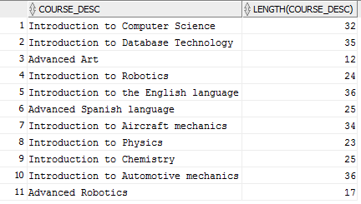

/*11. Use a column alias*/

SELECT /*fixed*/ Instr_FName AS InstructorName FROM Instr_Info;

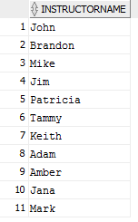

/*12. Perform an advanced query of your choice from chapter 8 (Database Systems Text Book - Coronel, Morris & Rob)*/

/*Return Instructor Full Name in following format: Last, First*/

SELECT /*fixed*/ Instr_LName || ', ' || Instr_FName AS InstructorName FROM Instr_Info;

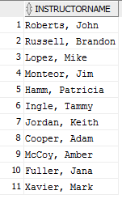

/*13. Use an aggregate function and perform another query*/

/*Return total number of course hours taught for each active class*/

SELECT /*fixed*/ Course_Name, SUM(Course_Hours) AS Total_Hours

FROM Course_List INNER JOIN Instr_Classes ON Course_List.Course_Num=Instr_Classes.Course_Num

GROUP BY Course_Name;

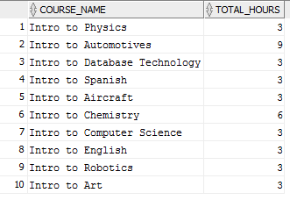

/*14. Use the UPDATE command and change some data.*/

SELECT /*fixed*/ * FROM Course_List;

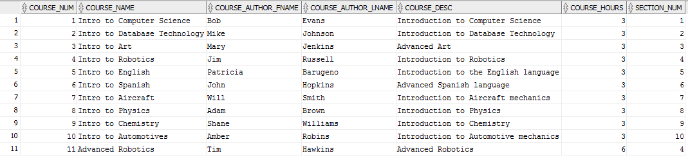

UPDATE Course_List SET Course_Hours=Course_Hours+1;

11 rows updated.

SELECT /*fixed*/ * FROM Course_List;

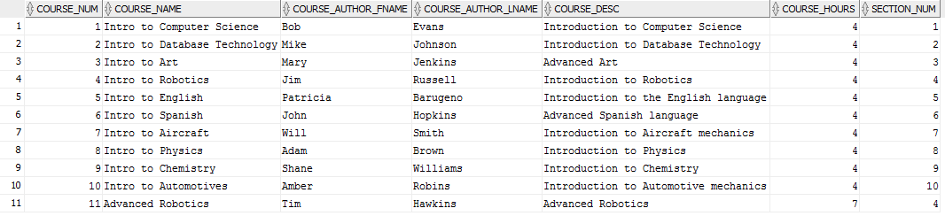

ROLLBACK;

Rollback complete.

/*15. Write an advanced SQL statement with a type I subquery (chapter 8).*/

/*Return list of Instructors teaching classes with "Auto" in course name using Type I query*/

SELECT /*fixed*/ Instr_Num, Instr_LName, Instr_FName

FROM Instr_Info

WHERE Instr_Num IN

(SELECT Instr_Num FROM Instr_Classes INNER JOIN Course_List

ON Instr_Classes.Course_Num=Course_List.Course_Num

WHERE Course_Name LIKE '%Auto%');

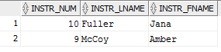

/*16. Write an advanced SQL statement with type II subquery (chapter 8).*/

/*Return list of Instructors teaching classes with "Auto" in course name using Type II query*/

SELECT /*fixed*/ Instr_Num, Instr_LName, Instr_FName

FROM Instr_Info

WHERE EXISTS

(SELECT * FROM Instr_Classes INNER JOIN Course_List

ON Instr_Classes.Course_Num=Course_List.Course_Num

WHERE Instr_Info.Instr_Num=Instr_Classes.Instr_Num

AND Course_Name LIKE '%Auto%');

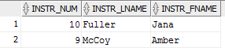

/*17. Perform additional advanced SQL statement. (chapter 8).*/

/*Return a list of courses and how many times they are currently being taught*/

SELECT /*fixed*/ Course_Name, COUNT(Instr_Classes.Course_Num) AS TimesTaught

FROM Course_List LEFT JOIN Instr_Classes

ON Instr_Classes.Course_Num=Course_List.Course_Num

GROUP BY Course_Name

ORDER BY TimesTaught;

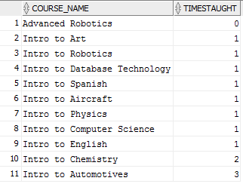

/*18. Perform additional advanced SQL statement. (chapter 8).*/

/*Return all Instructor names, class rooms, and courses taught*/

SELECT /*fixed*/ a.Instr_LName, a.Instr_FName, b.Class_Room, c.Course_Name

FROM (Instr_Info a LEFT JOIN Instr_Classes b ON a.Instr_Num=b.Instr_Num)

LEFT JOIN Course_List c ON b.Course_Num=c.Course_Num;

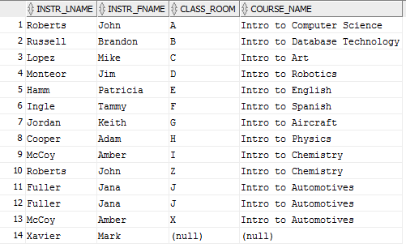

/*19. Perform additional advanced SQL statement. (chapter 8).*/

/*Return a list of sections not currently offering any courses*/

SELECT /*fixed*/ Section_Name

FROM Section_Info

WHERE NOT EXISTS

(SELECT Section_Num FROM Course_List

WHERE Course_List.Section_Num=Section_Info.Section_Num);



/*20. Perform additional advanced SQL statement. (chapter 8).*/

/*5 table join-Show all courses being taught with Section & Instructor Name,

Class Room, and Schedule; ordered by Section and Instructor last name*/

SELECT /*fixed*/ e.Section_Name, a.Instr_LName || ', ' || a.Instr_FName AS Instructor,

b.Class_Room, c.Course_Name, d.Sched_Day || ', ' || d.Sched_Time AS Schedule

FROM (((Instr_Info a INNER JOIN Instr_Classes b ON a.Instr_Num=b.Instr_Num)

INNER JOIN Course_List c ON b.Course_Num=c.Course_Num)

INNER JOIN Class_Sched d ON b.Sched_Num=d.Sched_Num)

INNER JOIN Section_Info e ON a.Section_Num=e.Section_Num

ORDER BY e.Section_Name, a.Instr_LName;

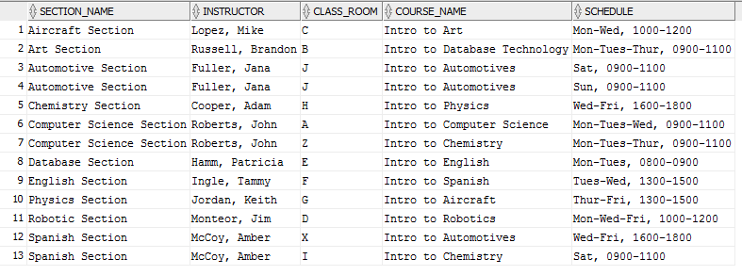

# Conclusion

This was a challenging project and I learned quite a lot from it. The more important things I felt I learned are as follows:

1. SQL Developer is a very powerful tool for database development. When I first started using it I thought it was just a simple tool for creating SQL statements. However, I quickly realized it is a very effective management tool and encompasses everything needed to create and maintain databases. Being able to utilize the query builder when creating select statements made creating queries much more efficient. Additionally, having a bird’s eye view of all the tables proved an effective multiplier in development.
2. I was unfamiliar with triggers before I began working on this project. I now know triggers are very powerful miniature programs embedded within a SQL file which can fire on specific events, similar to event-driven programming. In my project I was able to use a trigger to print a message to the screen when a new row of data was inserted into a table.
3. I knew of the JOIN operator before the beginning of this project, but this project has deepened my understanding of their true power. For example, I was able to create a join between two tables and then use a subquery to return a list of Instructors teaching classes about “Auto” with the LIKE operator. I was also able to use a LEFT JOIN and aggregate function together to compile a list of how many times a course was being taught.
4. I have built many databases in the past, but before this project creating an ERD was almost an afterthought. I now understand having an ERD with a properly laid out database design is a crucial step before you begin writing code. I referenced my ERD during all parts of this project and it proved to make my coding more efficient.
5. My Instr_Classes table is a weak entity. With that I was unsure what would happen if I deleted a referenced entity instance in my parent tables. During this project I learned about the “ON DELETE CASCADE” operator. This is a very important operator as it will ensure any entity instance in the child table is deleted if their associated parent table entity instance is deleted.